Apress LightSwitch 2012 by Tim Leung – Chapter 12

This chapter shows you how to use and create custom control extensions.

HelpDesk Project
To run the LightSwitch HelpDesk application, you’ll need to carry out the following tasks.
- Install the Microsoft Many-to-Many control extension (ManyToManyControls.VSIX). You’ll find this in the Setup folder, or you can download it from the Microsoft website.
- Install the ApressExtensionCS or ApressExtensionVB VSIX file.

Extension Projects
To run the extension project,
- Install the LightSwitch Extensibility Toolkit. You’ll also need to install the Visual Studio SDK, and copy the Microsoft.LightSwitch.Toolkit.targets file into your %ProgramFiles%\MSBuild\Microsoft\VisualStudio\LightSwitch\v2.0 folder. You’ll find full instructions in the Extensibility Toolkit’s readme file.
- In your Client project, make sure that the reference to your ApressControlsVB or ApressControlsCS DLL file is correct.
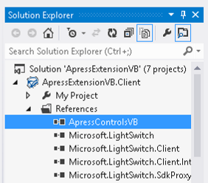
Tim Leung

